2020

Redhill Road Runners
7/29/2020
Redhill Road Runners Zoom Annual General Meeting
Annual General Meeting

- Agenda
- Attendance
- Approval of last year’s minutes
- Matter arising from last year’s minutes
- Chairman’s Report
- Treasurer’s Report & Finance sheet
- Brief Reports from officers
Membership
Coach
Social Secretary
Fell Running
Road Running
Cross Country
Kit Secretary Report
Communication Report
- Election of officers
- Any other business

Attendance
Attendees present - 26
Leigh Stubbs (Chair), Mark Davis, Wendy Lawson, Dave Walsh, Simon Nash, Peter Henley, Kate Horton, Toni Harper, Mike McHardy, Valerie Walker, Francesco Lari, Clive Greyson, Peter McNally, John Kelley, Mike Monks, Kathryn Walsh, Wez Annison, Ray Poynter, Vivienne Craven, Phil James, Michael Drury, Christopher Ward, Rosemary Horn, Stephen Gibson, Jeanette Barnes, Keith Palmer
This year’s AGM was carried out on Zoom virtually due to the meeting restrictions created by Covid19.
Meeting commenced at 20:05

Approval of last year’s minutes
Minutes of the previous year’s meeting were approved by show of hands on screen

Matters arising from last year’s minutes
No matters arising

Chairman’s Report
(Read by Leigh Stubbs)
Thank you to everyone for attending tonight’s zoom meeting.

I’d like to start by thanking the rest of the committee for their help and support, as they know it’s not an easy job to run a club as it takes a lot of time and work but this is made a lot easier with their help and support. So again, thank you.

I would also like to take the time to thank Dave Walsh and Kevin Dickinson for making sure the club tent is at all the races and also to the group leads for all the hard work they do.

On the running scene we are seeing a big increase in members competing and turning out for the club, this is the first time in a long time that we have had teams finish in the Midland & Nationals XC. We have also had success with our C25K & C210k course over the year and would like to thank Wendy, Hayley and the run leaders for all their work.

The social side of the club has been great again this year like most years which has been down to Peter Henley who unfortunately is stepping down, I would to thank him for all the work he put in over the years organizing same great events for the club.

I say this every year, but I genuinely mean it, this is a great club to be chairman of and that is down to its members.
Treasurer’s Report
(read by David Walsh and prepared by Hayley Purdy - not present)

Please see below for accounts sheet, a full copy will also be available on the club website.

The club accounts were approved by a show of hands as a vote.

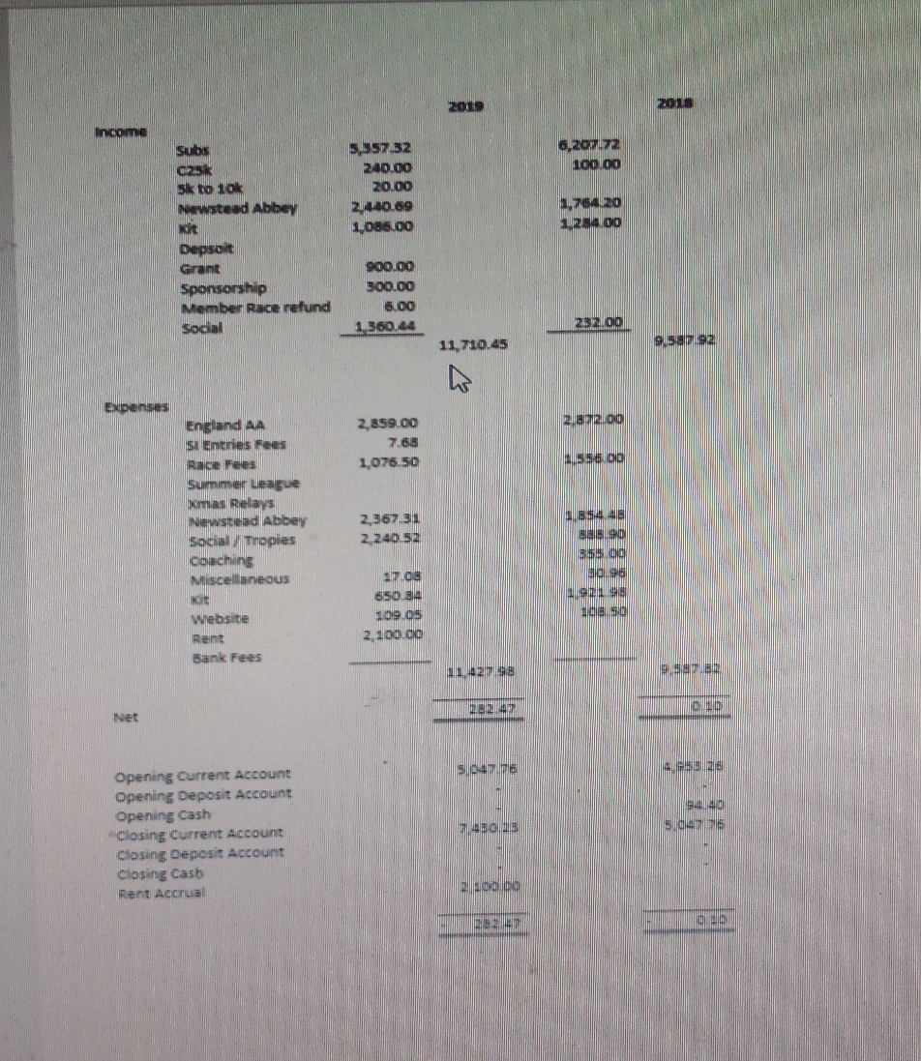

Membership Report
(Read by Leigh Stubbs and prepared by Martyn Newton – not present)

We had 170 paid up members in 2019 down 12 members from the previous year.

This year we have introduce online payments for membership as the club no long accepts cash payments for membership, we have also set up online membership form on the club website for new members.

Coach Report
(Read by Leigh Stubbs and prepared by Simon Nash - present)

I would like to thank all the run leaders and coaches for the hard work and commitment over the past year which is all voluntary.

It’s been rewarding seeing athletes progress though the year and achieve their goals and we can help them continue their journey.

Social Secretary's Report
(Read by Leigh Stubbs and prepared by Peter Henley - present)

I have decided to stand down as the social secretary this year. After several years i the role I feel it needs some fresh ideas.

Over the past year we have had some great social gatherings. There has been the usual outing, Dovedale, the Xmas meal and the BBQ. All of which were great gatherings.
There was also a great Redhill turnout at the Tenerife Bluetrail, representatives in all races....some were even successful. All were successful in the social aspect with the exception of Anthony Aram who spent the entire time suffering from Canary Flu. (Aaahhh)
There have been the usual gatherings at the Robin Hood which, for me at least, has become my spiritual home.

As we move forward with a new social secretary, I will echo what I have always said, that all are welcome to create group socials as and when they like. Heather Thornley did a number of these on a Friday. After the club social runs. Thank you Heather.

This year will see the return of our trip to the Keswick Mountain Festival. As much a social as a race.

One thing I have found since joining the committee, is the more you put into the club, the more you get out. I hope our new social secretary ﬁnds this to be the case.

Thank you for your support
Fell Running Secretary Report
(Read by Leigh Stubbs prepared by Peter Henley – present)

2019 was a great year for the fell running series. A total of 20 club members took part in races which were part of the series. 2020 promises to be another great year too. The Notts County fell champs once again is including 3 races, but the best bit is the introduction of an ultra. The PB57KM is a very user friendly ultra, with simple navigation and generous cut off times and 10 points awarded to all ﬁnishes. And for those who are still a bit unsure about an ultra, there is an 18km option on the same day.

We also have a weekend navigation course being offered by Ranger Ultras. This will take place on Sat 6th of June and Sunday 7th June and will cost between £50 & £90 depending on number. Only 6 people required to get it for the cheaper price.

Having done little running since the summer I am hoping to get out again soon for some social fell runs, and with a place in the 2021 Spine Challenger race I will be looking at doing some multi day training runs along the Pennine Way. Feel free to join me.

Remember fell running isn't about running up mountains, it’s about enjoying them by walking up them and running down. As always feel free to ask me for all aspects of fell running.

Road Running Report
(Read by Leigh Stubbs prepared by Francesco Lari – present)

Our road running season centers on the summer league and the county championship. In the overall summer league, we were awarded 6th place with the Senior Men, Veteran Men and Veteran Ladies teams, while the Senior Ladies were 9th. Individually Michelle Butler got second place in the FV45.

In the county championship congratulations to winners: Barbara Stevens (half marathon and 10 miles V55 Gold)

Second places: Paul Newton (10 miles MV45), Louise Woolley (10k FV35)

third places: Dave Walsh (half marathon MV55), Paul Newton (10k MV45), Dave Onion (10k MV75), Samantha Brown (10k FV45)

Cross Country Report
(Read by Leigh Stubbs prepared by Francesco Lari - present)

In cross country at the county championship Nigel Daniels won MV70 gold and Helen Burrell won FV55 gold, while the Ladies Senior team got 2nd place overall (Hannah Polak, Claire Martin, Helen Johnson Kolb). In the North Midlands XC League we got podiums with Paul Newton MV50 winner, Michael Horn 2nd MV70, Rosemary Horn 2nd FV60, Chris Ward 3rd MV55, The best placed team was the Male Vets 8th Overall.

At the British masters XC relays (also the Midland XC relays), the Ladies V45 team won British Masters Bronze & Midland Silver (Helen Burrell, Michelle Butler, Carolyn Hay),
while the Men V45 team got Midland Bronze (Paul Newton, Wayne Stott, Steve Gelderd, Kevin Dickinson, Simon Nash).

Kit Report
(Read by Leigh Stubbs prepared by Wendy Lawson - present)

Although we have had to purchase same additional male vest/shirts, in the popular sizes, very little has changed with regard to the club stock. All orders for kit are complete. I am looking into getting ‘bandanas’ for the club, I will endeavor to get a costs for the next committee meeting so that it can be decided one way or another.

I prefer to allow club members to request kit, rather then me badgering folk to buy it. However, if folk do want kit please contact me and place an order.

Communications Report
(report was not read out at the meeting, prepared by Kate Horton - present)

Period of report: April 2019 to March 2020

The communications for Redhill Road Runners is operating at a functional level. The largest amount of digital traffic for the club is directed through the Facebook page with smaller amount of traffic twitter and the club website.

Current website content
The current RRR website contains lots of information and is worth a look through for new and old members.

During the period of the report a club kit page has been added so visitors can see what is held in stock, how much it is and how to order.

Race details on the website and Grand Prix standing are updated by Leigh Stubbs and David Walsh respectively.

Content on Social Media
Facebook
The Redhill Road Runners Facebook group is the most active stream for the club with 367 members and the most up to date with club information.

Twitter
The club currently runs two twitter accounts: @Redhill_RR and @NewsteadDash.

Activity on these is limited to running chatter, event information and race specifics relating to the Newstead Dash.

Election of Officers

Position | Name | Standing  Y/N | Nominee  (Name) | Proposed By | Seconded By
Chairman | Leigh Stubbs | Y
Vice Chairman | Mark Davis | Y
Vice Chairman | Dave Walsh | Y
Secretary | Val Walker | N | Kate Horton | Leigh Stubbs | Peter Henley
Treasurer | Hayley Purdy | Y
Membership | Martyn Newton | N | Mike McHardy | Mark Davis | Toni Harper
Social | Peter Henley | N | Toni Harper | Leigh Stubbs | Mike McHardy
Social | Peter Henley | N | Val Walker | John Kelley | Leigh Stubbs
Kit | Wendy Lawson | Y
Coach | Simon Nash | Y
Communications | Kate Horton | Y
Summer League | Francesco Lari | N | Clive Greyson | Leigh Stubbs | Mark Davis
Cross Country | Francesco Lari | N | Peter McNally | Leigh Stubbs | Mark Davis
Male team Manager | Leigh Stubbs | Y
Female team Manager | vacant |  | Val Walker | Leigh Stubbs | John Kelley
Race Director | Leigh Stubbs | Y
Committee Member | Martin Lee | Y
Committee Member | vacant
Fell | Peter Henley | Y

Firstly, Leigh and the rest of the committee would like to say a big think you to Peter Henley, Francesco Lari, Martyn Newton and Val Walker who are stepping down from the committee for all your work and support over the year’s.

Secondly, we would like to welcome Mike McHardy, Toni Harper, Peter McNally and Clive Greyson on to the committee. Mike, Peter and Clive where vote onto the committee unopposed.

As there where two people going for the Social role Val Walker and Toni Harper, a vote had to be taken this was done by a show of hands. Toni Harper won the vote and was voted on to the committee.

Kate Horton offered to be Secretary and was vote on unopposed to be the New Secretary to go alongside her communication role.

Val Walker was vote back onto the committee as our new Ladies Team Manager, welcome back Val.

Any Other Business

There was no other business

Meeting Closed at: 20:34

