2019

3/20/2019

Annual General Meeting

Annual General Meeting
Agenda
Attendance 4
Present 4
Approval of last year’s minutes 5
Matters arising from last year’s meeting 5
Chairman’s Report 5
Treasurer’s Report 6
Income 6
Brief Reports from officers 8
Membership Secretary (read by Mark Davis) 8
Coach Report (read by Mark Davis) 8
Social Secretary 9
Fell Running Secretaries Report (read by Mark Davis) 10
2018 Road Race Report (as read by Mark Davis) 12
Cross Country (read out by Jo Stocks) 13
Kit Secretary Report 14
Constitution Amendment 15
Election of Officers 15
Any other business 18

Attendance
No head count was taken, but all those present were asked to write their names on the circulated sheet.
Present (39)

Paul Thompson, Kevin Dickinson, Jackie Dickinson, Valerie Walker, Wendy Lawson, Graham Webster, Pete McNally, Ben Wilson, Sophie Wilson, Clive Greyson, Dennis Reeson, Martyn, Newton, Nigel Fisher, Hayley Purdy, Martin Lee, Wayne Stott, Simon Nash, Lisa Doyle, Louise Wooley, Mike Monks, Leigh Stubbs, Mark Davis, Paula Wood, Dave Walsh, Tim Raynor, Sam Braun, Mark Tomo, Francesco Lari, Kate Horton, Claire Martin, Jo Stocks, Paul Newton, Kathryn Raynor, Mark ?, Paul Stacey, Chris Ward, Pete Kelly, Peter Henley, Michael Horn
The sheet did say print your name, but a couple of people decided to sign
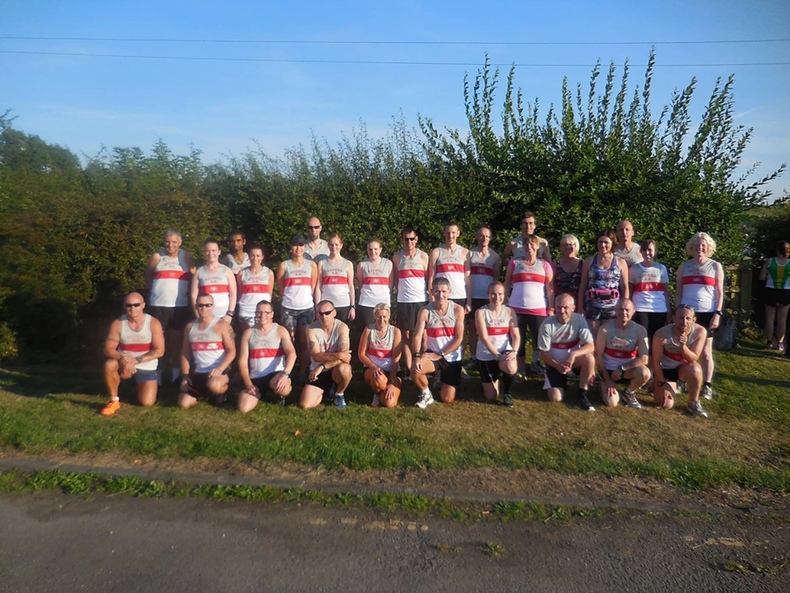
Meeting Started at 20.22

Approval of last year’s minutes

Signed off

Matters arising from last year’s meeting

None raised

Chairman’s Report
(Read by Leigh Stubbs)

Firstly, thank you all for attending tonight’s meeting.

The AGM will be held first followed by the presentation of the Grand Prix trophies and the awards that members have been voting on the past few weeks.

I’d like to start by thanking the rest of the committee for the help and support over the last year and for making my first year as chairman an interesting one. I would like also to thank the club coaches for all the hard work and sacrifices over the last year or so.

On the running scene, we have continued to see the club be successful with team and individuals winning medals over all distances and terrain, we have also had great success with our C₂5K course and our new 5₂10K course, thank you Hayley, Wendy and all the coaches for this.

The social side of the club is going from strength to strength and I would like to thank Peter for this and last, I’d like to thank you guys for making this a great club to train with and be part off.

Treasurer’s Report
As read by Hayley Purdy:

Income
Subs have doubled but this is because most people paid by bacs (2019), so the club has not had to wait for SI entries to put the money in the bank. The remainder of income matches last year.
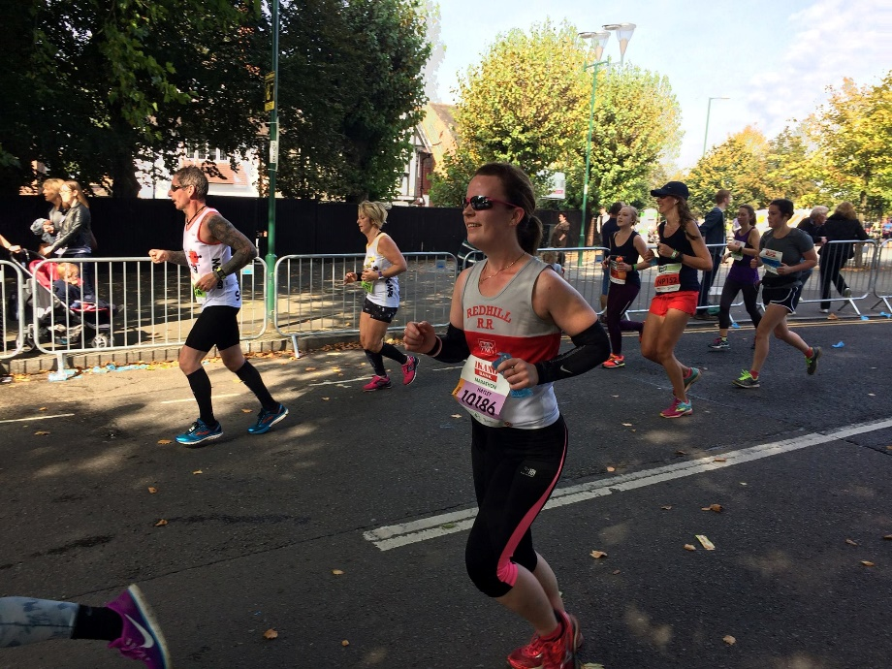Expenses
Newstead Abbey expenses were more as we had a timing chip system to make result processing easier. We paid for a coaching course for Simon Nash to become qualified.
Overall
Profit of 10p over the year.

Redhill Road Runners 2018 Financial Statements

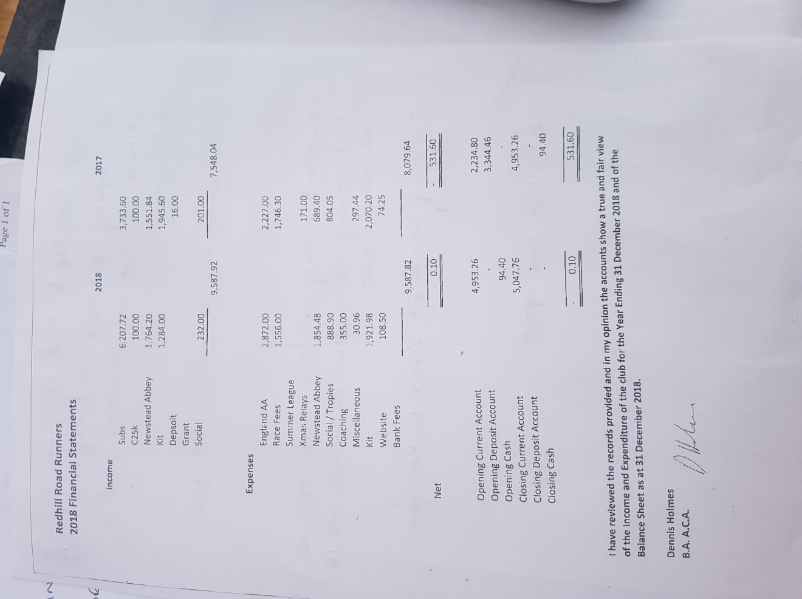

Brief Reports from officers

Membership Secretary (read by Mark Davis)
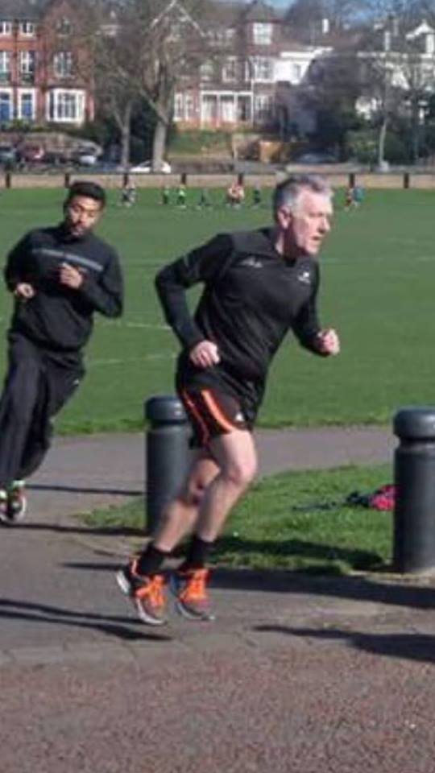
As per email:
There were 181 members in 2018 and 1 second claim member.

Coach Report (read by Mark Davis)

I would like to thank all the run leaders for all their hard work over the last year and in particularly all the athletes for turning up on some quite challenging sessions.

It’s been a pleasure watching individuals progress over the course of the year and achieve some fantastic results.

We hope to continue helping athletes as much as possible
So, they can keep improving and also enjoy their running.

Many thanks,

Simon Nash

Social Secretary

As always it has been a real pleasure telling people to go to the pub, and it seems to work too. There have been numerous other outings to though. The Xmas meal proving to be popular as always, French Living doing us proud.

The Dovedale Dash another Redhill favourite seems once again to be proving even more popular. Though I dream of us filling a double decker again.
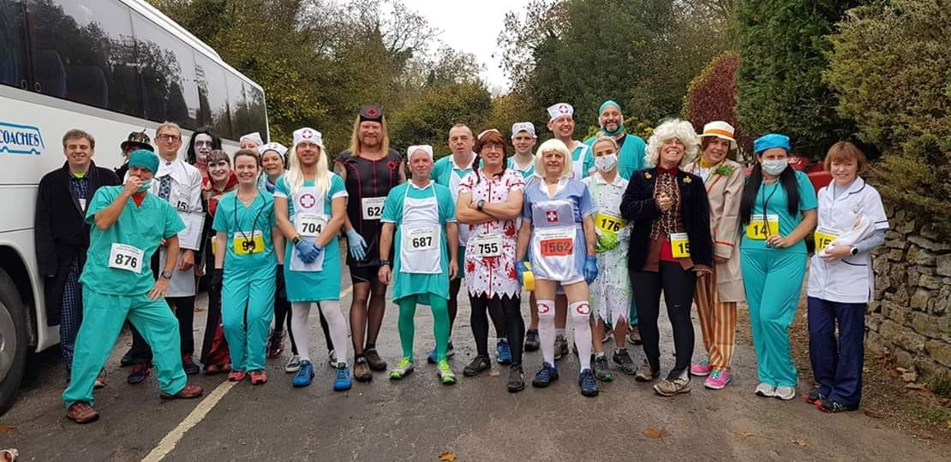

Both occasions were made all the more memorable thanks to the fun and games provided by Tamzin Yates. A big round of applause for her if you will.

Also, I’d like to thank Heather Thornley, who organised several Friday night post run socials. Again if you could show her your appreciation.

Other events like the Keswick Mountain Festival have also proven popular. Though this many of us will be swapping the lakes for the Tenerife Bluetrail Running Festival. I’m sure Redhill will do the club proud overseas.

Of course any of you are welcome to organise other social events should you choose, the more the merrier. Thanks again for another great year.

Fell Running Secretaries Report (read by Mark Davis)

After a somewhat slow start to the season due to adverse weather conditions, the 2018 series was rather successful. With 18 Redhill members taking part in the series. The split was 50/50, male and female. And the ladies numbers have continued to grow on our social fell runs. Keep it up, Ladies!
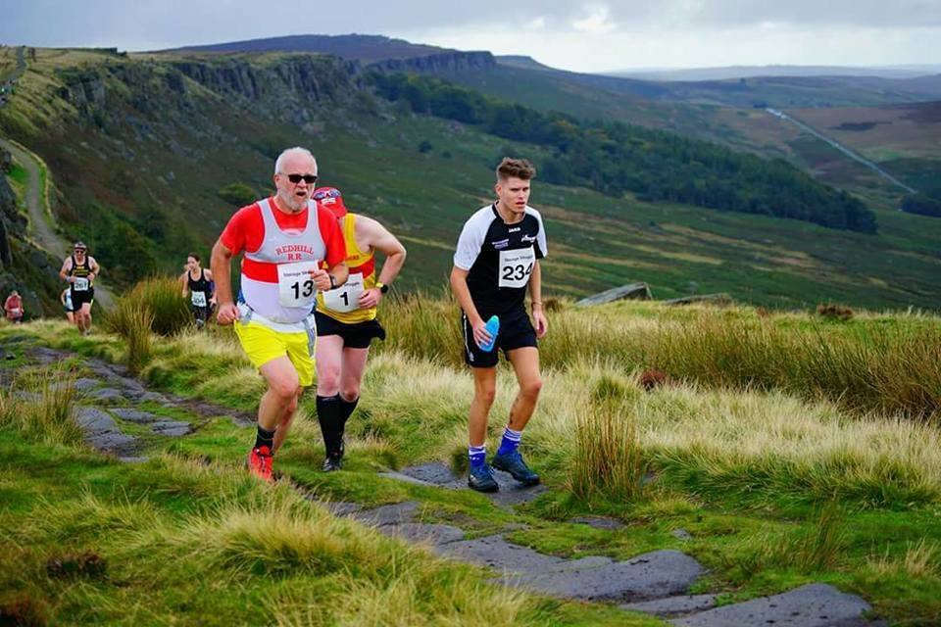

Looking at the points system of this series, it favours attendance over ability. Simply completing the most races COULD see an individual win the series.

Runners of all abilities have entered both races and social runs, and despite a level of anticipation from newcomers to the sport, all have thouroughly enjoyed it.

I will be taking some beginner sessions in the Peak District over the summer months for any of you, who want to give it a try, and the next race in the series is Pete’s Pit. This is ideal for all abilities. There is no need for extra kit and the terrain is no different to running around Bestwood Country Park. It is less than 5km too.

In case you are wondering what to expect, feel free to ask any of those who have joined me. Always expect cake or beer after though, and if you are wondering how the hell to run up a mountain? The answer is simple, we don’t, we walk up them.

2018 Road Race Report (as read by Mark Davis)

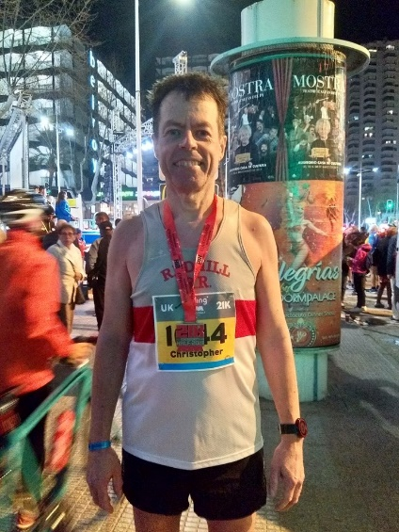
Our road running season centres on the Summer League and the County Championships. In the overall Summer League we got a silver with the veteran male team, while senior ladies and men were both 5th and the veteran ladies were 6^{th.} Individually Simon Nash and Peter McNally both got second place (V45 and V55) and Michelle Butler got 3rd place in F45.
In the county championships, congratulations to winners: Carolyn Hay (half marathon senior and V45), Chris Ward (marathon V55), Karl Mallyon (10 miles V35), Barbara Stevens (5K V55), Pete McNally (5K V55), Michael Horn (fell running V65).

Second places:
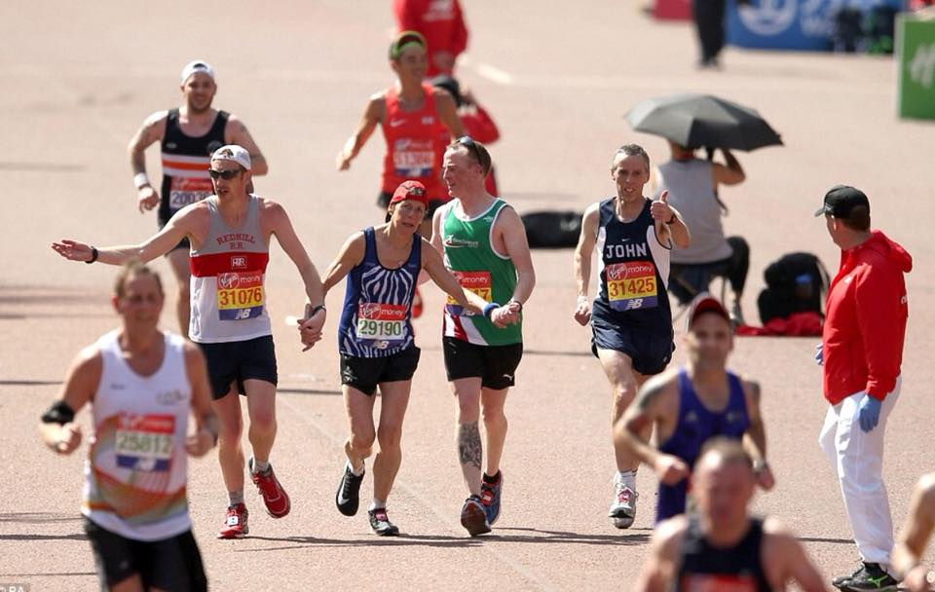
Mark Davis (marathon senior and V35), Ray Pointer (marathon V55), Dave Onion (half marathon V75), Simon Nash (10 miles V45), Barbara Stevens (10 miles and 10K V55).

Third Places: Karl Mallyon (10 miles senior), Andy Parsons (marathon V45), Gary Manson (marathon V55), Joanne Stock (marathon Stocks (marathon V35), Wayne Stott (10 miles V45), Samantha Brown (10 miles V45), Simon Nash (5K V45), Rosemary Horn (fell running V55).

Also congratulations to Helen Burrell who won the British K masters V55 title with a time of 19:05 minutes.

I would like to remember that the first run of the 2019 Summer League will be at Hexgreave Park on Wednesday April 24 (7:15pm). This years rules have changed and for both the senior and the veteran team there are now 5 gentlemen and 4 ladies to count ( up from 4 and 3 last year). This makes all the more important to attend and support your club. As usual the races are free and the only requirements are to be in order with the payment of your subs and to bring a Redhill vest. We are looking forward to see you there.

(Jo Stocks added to the report)

Helen Burrell got a masters gold in the 10K championship medal and Dave Walsh got a masters gold in the 20K walking championship medal. He was also ranked 2nd nationally for his age group.

Midland Counties Road Relays, Sutton Park 22/09/2018.

3 ladies and 3 men’s team entered, the stand out result was 8th for the men’s vets team.

Unfortunately we didn’t have enough interest to enter the 12 and 6 stage relays this weekend with it it clashing with Ashby 20 this year. I encourage all to put their name down, if you want to run as Redhill not fielding a team is letting the club down more than having slower runners in a team.

However entering a team does cost money, so worse for you to say yoou can run and then pull out in the days before. This has happened for men and ladies this year so maybe it is something we need to discuss.

Cross Country (read out by Jo Stocks)
Back onto Cross Country, starting back in September, we had the British Masters which we entered teams for which was at West Park.
We had 3 men's and 3 ladies at Berry Hill, we also entered a team at the Bulwell Hall 5 and 7 miles where the men came 5th in the team and the ladies 10th.
In the Notts county championships in the master’s men got team gold and masters ladies got team bronze. Pete McNally got men's 55 gold, Nigel Daniels men's 75 gold and Paul Newton got men's 45 bronze.
In the North Midlands the men vet got team silver, Simon Nash got V50 Bronze, and Pete McNally V55 Silver.
In the East Midlands Cross Country our men's A team came 6th and the B team came 5th
The men's vet team came 3rd overall and our vet ladies 5th and senior ladies 9th.

And we also sent 5 men to the National Cross Countries this February in Leeds.

And again, Cross Country is a bit like Summer league, It's free as the club pays the race entry fee and you just turn up, no matter what your ability is.

Kit Secretary Report ( read out by Mark Davis)

I (Wendy Lawson) took over the position of Kit Secretary at the last AGM and inherited approxiamately £1,600 worth of kit, namely hoodies, beanies, training tops, club vests and club T-shirts.

Over the last financial year the club has sold approxiamately £120 worth of kit, together with £132 of jackets which are pre-payable orders.

As the stocks for some of the smaller sizes of club vests and shirts are minimal, there is a six week turn around with the club’s suppliers. I would ask Club members to bear this in mind when requesting and subsequently finding out that particular sizes have to be ordred.

Just to retaliate all kit now has to be paid via the Club’s bank account (details of which can be found on the Club’s website). All orders should have the reference ‘ KIT – Surname of member’) to make payments clear to Hayley Purdy.

I find it easiear to deal with orders if they arrive by email and am happy to have my address (wendylawson385@gmail.com) visible on the club’s website for this purpose.

Constitution Amendment (addressed by Dave Walsh)

So, there's on constitution amendment we want to make this year and it's really just a matter of clarification people that pay fees are due on the 1st of January, and because it doesn't pacifically say it some people annually have been thinking that the payment made in January runs through to The April of the following year because that's when the EAA year. as it's been pointed out there's some ambiguity as to when the club year is. So the current constitution is that the That is not intended to be the case, so what we want to do is to just clarify that the club year ends on the 31st December.

So, this is a vote on that, the club year ends on December 31st. Dave asked, 'does anyone here want to ask any questions on that?'
Nobody answered and Dave asked for a show of hands on who was in favour of the year end being December 31st. The show of hands was unanimous, he then asked if anyone wanted to vote against, nobody raised their hand.

Election of Officers
(Leigh Stubbs speaking)
Chairman Leigh Stubbs, I'm standing
Vice Chairman Mark Davis, (turns to Mark) your standing?
Treasurer Hayley Purdy, standing
Membership secretary Martyn Newton, standing
Social Secretary Peter Henley, standing
Kit Secretary Wendy Lawson, standing
Coach Simon Nash, standing
Fell Coach Peter Henley, standing
Communications Jo Stocks, NOT standing so if anyone would like a position as a communications officer which basically involves updating the website with the results, doing twitter, and Facebook is anyone interested in that position at all? (no one stepped forward) Please say otherwise I'll end up doing it. I take that as a no then.
Summer League and Cross Country Francesco Lari, standing
Male team manager Leigh Stubbs, standing
Female team manager Jo Socks, NOT standing
Please can I have a show of hands for those that want the committee to be voted back in? (The show of hands was unanimous)
Now for the positions that are open, Secretary Phil James is standing down and the candidate is Val Walker, which has been nominated by me and seconded by Mark, does anyone object to that? Does anyone want to rival? Nope, so you are now secretary
No one wants communications
Jo Stocks explains that she is trying to get off Facebook, so that is why, part of the reason she isn't standing.
So basically, if you like using Facebook...
So, when Leigh sends out an event email, some people don't read their emails, so put it on Facebook and Twitter. When we have committee meetings updates, erm what's ever come about, event flyers and then update race results.
Dave Walsh goes onto explain that the communications role has changed over the years, as it used to be putting things in the Evening Post years ago. The new officer could do their communications differently. Leigh said he didn't mind a double act.
Leigh asked, 'Jo is also stepping down from team manager does any want to put their name forward?'
Jo explains that it is basically getting names together for the female teams and collecting tokens at the summer league. She then said she would like to thank Joanna Ward, (Chris Ward's wife) for collecting tokens at the end of the races at last year’s summer league with Wendy and other people, but she is not actually a club member. She took all and wrote down the names.
Cross Country is really easy because generally there's just me and Haley and then 4 or 5 other people might come along. You just have to collect the names.
Summer League is a little bit more, but we only had 26 ladies in the summer league last year so it's not a lot to cope with. Men's is a whole lot harder and then when we have the relays and cross countries getting people interested.
Leigh Stubbs asked if anyone was interested in that position? (no one came forward).
Dave Walsh explains that it is free entry for relays and that most club's charge.
(Leigh Stubbs speaking again) The next positions are 2 committee members which are basically rolling positions, which you can get drafted into anything. Martin Lee has put his name down for this one, as he's at most committee meetings. He's nominated by me and seconded by Mark. Does anyone object to that? No one raises their hand, we need one more if anyone's interested? Mark Davis adds you'll get see how the club's run.
Peter Henley then starts speaking ' I think Val's a good example how that can work out well because Val joined on last year as one of the additional committee members and now, she's doing a great job of taking all the minutes'.
And Jo Stocks adds and all the experience that you can put on your C.V. (everybody laughs).
Leigh Stubbs said he'd like to thank Jo and Phil James for all their help, and the rest of the committee for staying on of course.

Awards (read by Dave Walsh)

Grand Prix 2018 results, the ladies in reverse order:

3rd lady Lisa Doyle

2nd lady Sophie Wilson

1st lady Louise Woolley

1st vet 35 lady Jo Stocks

Grand Prix 2018 results, men’s in reverse order:

3rd man Simon Nash

2nd man Wayne Stott

1st man Paul Stacy

1st vet 35-man Mark Davis

1st vet 45-man Mark Webster

1st vet 55-man Dave Walsh

1st vet 65-man Michael Horn

Now for the other racing categories road racing, cross country and fell running. Starting with road racing:

Road Racing best man 2018 Karl Mallyon

Road Racing best lady 2018 Michelle Butler

Cross Country best man 2018 Wayne Stott

Cross Country best lady 2018 joint Jo Stocks and Bev Barnes

Fell Running best man Pete Henley

Fell Running best lady Sharman Paling-Codd

The Club Awards were awarded as follows:

Graham Dugdale Award 2018 Carolyn Hay

Dennis Warden Award 2018 Pete McNally

Clubman Award 2018 Leigh Stubbs

Endeavour Award 2018 Jo Stocks

Chairman’s Award 2018 Wendy Lawson

Leigh awarded this to Wendy for helping with the Coach²5K, the 5K²10K and the Newstead Abbey Dash. He also thanked Haley for helping with the coach²5K and 5K²10K.

Any other business
Councilor Michael Paine Labour

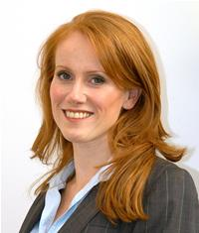
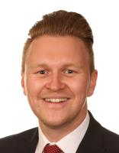
Francesco said he would like to thank the councilors that donated the fund to the club. Michael Paine from Labour and Sarah Hewson Independence Party.
Councilor Sarah Hewson

