Organised by Redhill Road Runners
www.redhillroadrunners.com

Newstead Abbey Dash 5K – Event Information
The big day will be upon us soon, so here’s some more details about what to expect to help your preparation.

Before you arrive.
• Do not attend if you are showing any symptoms of Coronavirus, in particular a new persistent cough or high
temperature.
• Do not attend if you have had a confirmed diagnosis of Coronavirus in the 14 days before the event.
• Do not attend if you have been told to self-isolate.

Event address: Newstead Abbey, Ravenshead, Nottinghamshire, NG15 8NA (Sat Nav Postcode: NG15 9HJ)

Directions: enter the grounds from the A60 end, not from Newstead village end (as there will be code barrier on the Newstead end)

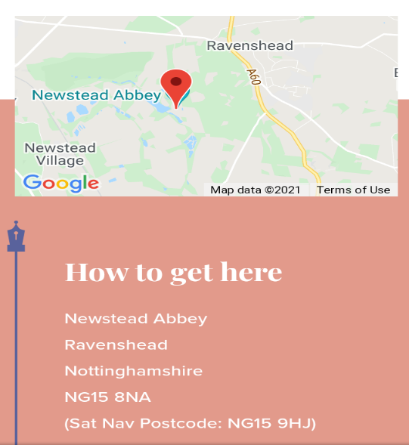

The site is open for you to arrive from 5.45pm

Parking
Follow the main drive down towards the house. The car park will be signed and marshalled
on your right. No unauthorised vehicles beyond the car park and please do not
park on the main drive or the course.

Registration
All participants must collect their bib numbers from the registration area on the grass a opposite the finish area. There will be a socially distanced queuing system in place, allow time to collect your number and walk / jog to the start as the start is around 1k uphill from registration.

Race Start
The 5K will start at 7.15pm, Please allow time to get from registration to the start line as
the start is around 1k uphill from the registration.

The Course
5k race run over an accurately measured out and back course. The course is fast and flat on
surfaced roads with a downhill start and only slight inclines. Distance markers will be at
every kilometre.
When running please keep to the lift head side of the course and follow marshals’
instructions.

In line with UKA rules and our race rules, headphones are not permitted, and their usage will
result in disqualification

Race Finish
On the grassy area adjacent to Newstead Abbey House in front of the lake. There will be
water for runners after the race in this aera, there will be no entry into the finish aera.

Toilets
Toilets are located through the gate next to the ranger’s office. Follow the sign to the gardens.

First Aid Cover
St John’s personnel will be on duty throughout the event.

Bag Storage
Unfortunately, there will be no bag storage this year.

Podium Presentation
Trophies and prizes will be awarded as soon as possible after the race as finished.

No competitor will be awarded more than one individual prize. Should a veteran finish 1st,
2nd and 3rd overall then they will be awarded the major prize and the veteran prize
will be awarded to the next eligible finisher.

Prizes and categories for the 5k.
1st male and female overall - Trophy and Cash Prize.
2nd male and female overall - Trophy
3rd male and female overall - Trophy
1st under 17 male and female – Trophy and prize
1st under 20 male and female – Trophy and prize
1st 35-44 male and female – Trophy
1st 45-54 male and female – Trophy
1st 55-64 male and female – Trophy
1st 65-74 male and female – Trophy
1st 75+ male and female – Trophy

NOTTS AAA 5K COUNTY CHAMPIONSHIP

See http://www.nottsaaa.org/
for County Championships Rules including eligibility criteria.
eligible for County Championships and all UKA registered County Championship
entrants must run in the colours of their first claim club or county/national colours.

Championship Awards are gold, silver, and bronze in the following categories: Men’s Open,
MV35, MV45, MV55, MV65, MV75. Ladies’ Open, LV35, LV45, LV55, LV65, LV75.
Veteran runners can win open category medals as well as their age category for the county
championship.

We look forward to seeing you on the night and hope you enjoy our race.

